These types of questions are called **"Conceptual Questions"** or **"Why-Based Questions"** in interviews. They are designed to test:

1. **Your Understanding of Core Concepts** – Whether you know the reason behind a language feature.
2. **Your Ability to Compare and Analyze** – Whether you can differentiate between different constructs.
3. **Your Practical Knowledge** – Whether you understand real-world use cases and limitations.

**Common Categories of Such Questions**

1. **Conceptual Questions** – "Why was the for-each loop introduced in Java?"
2. **Comparative Questions** – "What is the difference between for loop and for-each loop?"
3. **Design Choice Questions** – "Why does Java not support multiple inheritance?"
4. **Historical Questions** – "Why was Java designed to be platform-independent?"
5. **Optimization Questions** – "Which loop is better in terms of performance?"

**if for loop was already present in java then why did they introduced for each loop?**

Java originally had the traditional for loop, but the enhanced for loop (for-each loop) was introduced in Java 5 to make iteration over collections and arrays easier, safer, and more readable.

Key Reasons for Introducing the For-Each Loop

Improved Readability

The for-each loop simplifies iteration by eliminating the need for index management.

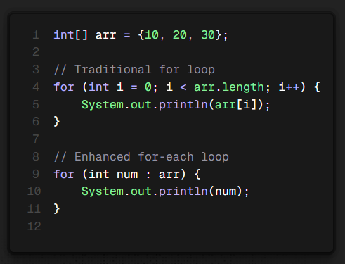

The for-each loop removes the need for arr[i] and length checks.

Avoids Index Errors

In traditional loops, off-by-one errors or incorrect indexing can lead to exceptions.

The for-each loop automatically handles iteration without needing to access indices.

Better for Iterating Collections

Works directly on ArrayList, HashSet, HashMap, etc., without using iterator explicitly.

Example:

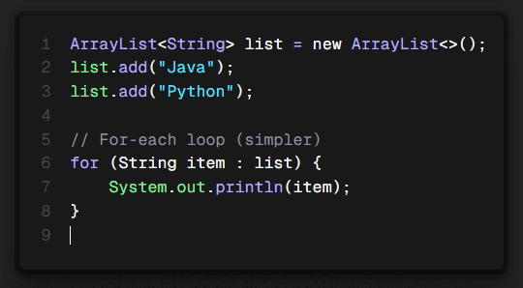

* + No need for get(i) or Iterator.

1. **Prevents Modification Issues**
   * The for-each loop **does not allow modification** (adding/removing elements), preventing ConcurrentModificationException.
2. **More Concise & Efficient Code**
   * Less boilerplate, making code easier to write and maintain.

**Limitations of the For-Each Loop**

1. **Cannot Modify the Collection**
   * You cannot remove elements directly during iteration.
   * Example (This causes an error):

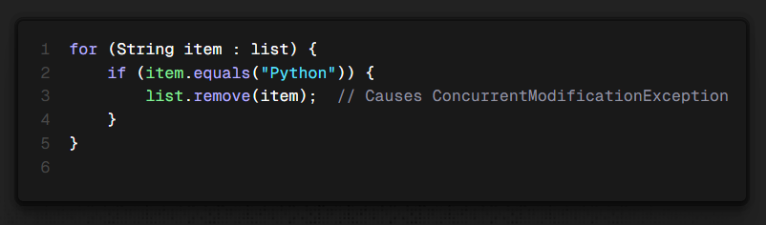

* • Instead, you must use an **Iterator**.

• **No Access to Index**

* You cannot get the index of the current element like in a traditional loop:

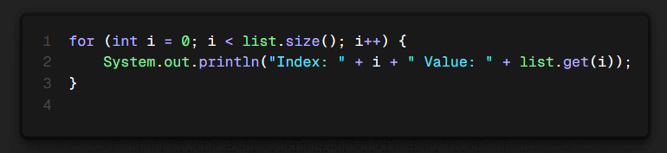

* + If you need an index, the traditional for loop is better.

1. **Only Works on Iterable Objects**
   * It cannot be used for non-iterable data structures.
2. **When to Use Each Loop?**

| **Loop Type** | **When to Use** |
| --- | --- |
| **Traditional for loop** | When index manipulation is required |
| **For-each loop** | When simply iterating through elements |
| **While/Do-while loop** | When the number of iterations is unknown |

1. **Conclusion**
2. The **for-each loop** was introduced in Java **to improve readability, reduce errors, and simplify iteration** over collections and arrays. However, it does not replace the traditional for loop in scenarios where index-based access or modification is needed.

**Difference Between Error and Exception in Java**

| **Feature** | **Error** | **Exception** |
| --- | --- | --- |
| **Definition** | A serious issue that occurs at runtime and cannot be handled. | A condition that disrupts the program's normal flow but can be handled. |
| **Cause** | Usually caused by system-level issues (e.g., memory overflow, JVM crash). | Usually caused by logical errors in code (e.g., divide by zero, null pointer access). |
| **Recoverable?** | **No**, errors are generally not recoverable. | **Yes**, exceptions can be caught and handled using try-catch. |
| **Handled in Code?** | Not meant to be caught using try-catch. | Should be handled using try-catch or throws. |
| **Examples** | StackOverflowError, OutOfMemoryError, VirtualMachineError | NullPointerException, ArithmeticException, IOException, SQLException |
| **Package** | java.lang.Error | java.lang.Exception |
| **Occurs Due to?** | Hardware/Software failures, JVM issues. | Programming mistakes or incorrect logic. |